**PROFESSIONAL TRAINING - I**

**at**

**Sathyabama Institute of Science and Technology (Deemed to be University)**

Submitted in partial fulfilment of the requirements for the award of a Bachelor of Engineering Degree in Computer Science and Engineering

By

**Name: K.Abhinav**

(**Reg. No:** **41110666**)



**DEPARTMENT OF COMPUTER SCIENCE AND ENGINEERING SCHOOL OF COMPUTING**

**SATHYABAMA INSTITUTE OF SCIENCE AND TECHNOLOGY JEPPIAAR NAGAR, RAJIV GANDHI SALAI,**

**CHENNAI – 600119, TAMILNADU**

**October 2023**

**SATHYABAMA**

**INSTITUTE OF SCIENCE AND TECHNOLOGY**

(DEEMED TO BE UNIVERSITY)

**Accredited with Grade “A++” by NAAC | 12B status by UGC |Approved by AICTE**

**(Established under Section 3 of UGC Act, 1956)**

**JEPPIAAR NAGAR, RAJIV GANDHI SALAI, CHENNAI– 600119**

www.sathyabama.ac.in

**DEPARTMENT OF COMPUTER SCIENCE AND ENGINEERING**

**BONAFIDE CERTIFICATE**

This is to certify that this Project Report is the bonafide work of **K.Abhinav (41110666)** who carried out the project entitled “**Vehicle Service Application**” under my supervision from JULY 2023 to OCTOBER 2023.

**Internal Guide**

### Name: MS.R.YOGITHA

**Head of the Department**

**Dr. L. Lakshmanan M.E., Ph.D.**

**Submitted for Viva-voce Examination held on _________________________**

**Internal Examiner External Examiner**

**DECLARATION**

I **K.Abhinav (41110666)** hereby declare that the Project Report entitled **“Vehicle Service Application”** Done by me under the guidance of **MS.R.YOGITHA** (Internal) at **HCL** is submitted in partial fulfilment of the requirements for the award of Bachelor of Engineering degree in Computer Science and Engineering.

**DATE:**

**PLACE:**

**SIGNATURE OF THE CANDIDATE**

**ACKNOWLEDGEMENT**

I am pleased to acknowledge my sincere thanks to **the Board of Management of SATHYABAMA** for their kind encouragement in doing this project andcompleting it successfully. I am grateful to them.

I convey my thanks to **Dr. T. Sasikala M.E., Ph.D., Dean**, School of Computing, **Dr.L.Lakshmanan M.E., Ph.D.,** Head of the Department of Computer Science and Engineering for providing me with necessary support and details at the right time during the progressive reviews.

I would like to express my sincere and deep sense of gratitude to my Project Guide **MS.R.YOGITHA** for her valuable guidance, suggestions and constant encouragement paved way for the successful completion of my project work.

I wish to express my thanks to all Teaching and Non-teaching staff members of the **Department of Computer Science and Engineering** who were helpful in many ways for the completion of the project.

**TRAINING CERTIFICATE**

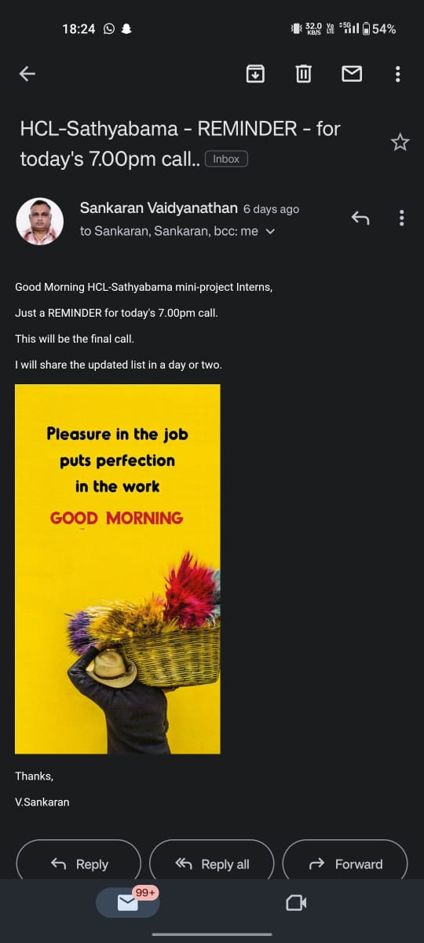

**ABSTRACT**

* **Vehicle Service Application** are becoming increasingly popular, offering a convenient and efficient way for vehicle owners to book and manage their service appointments. These websites typically allow users to select a service center, schedule an appointment, and view the status of their service in real time. Some websites also offer additional features such as vehicle maintenance reminders, service history tracking, and online payments. This vehicle service application project aims to develop a comprehensive and user friendly app that meets the needs of both vehicle owners and service centers.
* **Key Features:**

1. Book and manage service appointments online
2. Schedule appointment with the service providers.
3. View the status of service in real time
4. Track their vehicle’s maintenance history.
5. Can order parts for their vehicles
6. Get information on recalls, maintenance schedule and repair costs
7. Make online payments seamlessly
8. Inventory management: Vehicle service businesses can use the website to track their inventory of parts and supplies.
9. Customer relationship management (CRM): Vehicle service businesses can use the website to track customer interactions and manage their customer relationships

**TABLE OF CONTENTS**

|  |  |  |
| --- | --- | --- |
| **CHAPTER NO.** | **TITLE** | **PAGE NO.** |
|  | ABSTRACT |  |
| 1 | INTRODUCTION | 1 |
| 2 | AIM AND SCOPE OF THE PRESENT INVESTIGATION  2.1. AIM  2.2. SCOPE | 2  2-3 |
| 3 | EXPERIMENTAL MATERIALS AND METHODS USED  3.1. MATERIALS  3.2. METHODS | 4  4-5 |
| 4 | RESULTS AND DISCUSSION, PERFORMANCE ANALYSIS  4.1 RESULTS  4.2 DISCUSSION  4.3 PERFORMANCE ANALYSIS | 6  7  7-8 |
| 5 | SUMMARY AND CONCLUSIONS | 9 |
|  | REFERENCES | 10 |
|  | APPENDIX  A. SOURCE CODE  B. SCREEN SHORTS | 11-14  15-16 |

**LIST OF FIGURES**

|  |  |  |
| --- | --- | --- |
| **FIG. NO.** | **FIGURE NAME** | **PAGE NO.** |
| 1 | LOGIN PAGE | 14 |
| 2 | MAIN PAGE | 15 |
| 3.1 | CATEGORY PAGE | 15 |
| 3.2 | SHOPPING PAGE RESULT | 16 |
| 3.3 | CART RESULT PAGE | 16 |

**CHAPTER 1**

**INTRODUCTION**

A vehicle service application project is a software development project that aims to create a mobile or web application that helps users book and manage vehicle services. This can include a wide range of services, such as oil changes, brake repairs, tune-ups, and more.

Vehicle service applications can offer a number of benefits to users, including:

**Convenience**: Users can book and manage services 24/7 from their smartphone or computer.

**Transparency**: Users can see pricing and service details upfront.

**Peace of mind**: Users can feel confident that their vehicle is being serviced by qualified professionals. And many more.

Here are some of the key features that a vehicle service application should include:

**Online booking**: Users should be able to book services online or through the app.

**Service history**: Users should be able to view their vehicle's service history and track upcoming appointments.

**Push notifications**: Users should receive push notifications for upcoming appointments and service reminders.

**Payment processing**: Users should be able to pay for services directly through the app.

**Customer support**: Users should be able to contact customer support directly through the app if they have any questions or problems.

**CHAPTER 2**

**AIM AND SCOPE OF THE PRESENT INVESTIGATION**

**2.1. AIM:**

The aim of a vehicle service application is to provide a convenient and efficient way for vehicle owners to manage and schedule their vehicle maintenance and repairs. The application should also help vehicle service providers to manage their appointments and inventory.

**2.2. SCOPE:**

1. . **Vehicle registration and management**: Vehicle owners should be able to register their vehicles with the application and provide information such as the make, model, year, and mileage. The application should also allow vehicle owners to manage their vehicle information, such as adding or removing vehicles from their account or updating their contact information.
2. **Service scheduling and management**: Vehicle owners should be able to schedule services with the application, such as oil changes, tune-ups, and brake repairs. The application should also allow vehicle owners to manage their scheduled services, such as rescheduling or canceling appointments.
3. **Service history tracking**: The application should track the service history of each vehicle, including the dates and types of services that have been performed. This information can be used by vehicle owners to keep track of their vehicle maintenance and by vehicle service providers to identify repeat customers and potential service opportunities.
4. **Reminders and notifications**: The application should send reminders to vehicle owners when their vehicles are due for service. The application can also send notifications to vehicle owners about other important information, such as special offers or service recalls.
5. **Payment processing**: The application should allow vehicle owners to pay for services online or through the app. This can make it easier and more convenient for vehicle owners to pay for their services.
6. **Parts ordering**: The application can allow vehicle owners to order parts for their vehicles. This can make it easier for vehicle owners to get the parts they need for their repairs.
7. **Customer reviews**: The application can allow vehicle owners to leave reviews of vehicle service providers. This information can be helpful for other vehicle owners when choosing a service provider.

**CHAPTER 3**

**EXPERIMENTAL MATERIALS AND METHODS USED**

Developing a Vehicle Service Application/website for an organization involves a combination of materials and methods that encompass various stages of development. Here, we outline the essential materials and methods for creating such a website:

**3.1. Materials:**

1. **Development Environment:** A computer with a suitable operating system (e.g., Windows, Linux, macOS).Integrated Development Environment (IDE) or code editor. Required software and libraries for web development.
2. **Software**: This may include operating systems, programming languages, databases, and web development frameworks.
3. **Data**: This may include vehicle registration information, service history data, and payment information.
4. **Web-Development:** A web development framework might be used to create a web-based version of the application that can be accessed from any device with a web browser.

**3.2. Methods:**

1. **Database storage**: Vehicle service applications typically use a database to store information about vehicles, services, and customers. This database can be used to track vehicle maintenance history, schedule appointments, and process payments.
2. **Web services**: Vehicle service applications may use web services to communicate with other systems, such as vehicle diagnostic equipment or customer relationship management (CRM) software. This can allow the application to automate tasks and provide users with more information.
3. **Push notifications**: Vehicle service applications can use push notifications to send reminders to users about upcoming appointments or other important information
4. **Payment processing**: Vehicle service applications can use payment processing services to allow users to pay for services online or through the app.

**CHAPTER 4**

**RESULTS AND DISCUSSION, PERFORMANCE ANALYSIS**

**4.1. RESULTS:**

Vehicle service applications can deliver a number of benefits to both vehicle owners and vehicle service providers.

1. **Convenience**: Vehicle owners can use vehicle service applications to schedule appointments, track their service history, and pay for services online or through the app. This can save them time and effort.
2. **Transparency**: Vehicle service applications can provide vehicle owners with more transparency into the cost of services and the status of their vehicle. This can help them to make informed decisions about their vehicle maintenance.
3. **Peace of mind**: Vehicle service applications can help vehicle owners to stay on top of their vehicle maintenance and avoid unexpected breakdowns. This can give them peace of mind knowing that their vehicle is in good condition.
4. **Increased efficiency**: Vehicle service applications can help vehicle service providers to streamline their operations and improve their efficiency. For example, applications can automate tasks such as appointment scheduling and payment processing.
5. **Improved customer service**: Vehicle service applications can help vehicle service providers to improve their customer service by providing customers with more convenient and transparent ways to interact with their business.
6. **Increased revenue**: Vehicle service applications can help vehicle service providers to increase their revenue by generating new leads and encouraging customers to return for repeat business.

Overall, vehicle service applications can be a valuable tool for both vehicle owners and vehicle service providers. By providing a convenient, transparent, and efficient way to manage vehicle maintenance, these applications can help to improve the overall experience for everyone involved.

**4.2. DISCUSSION:**

* Allow customers to discuss their service needs with a technician before the service is performed. This can help to ensure that the customer's needs are clearly understood and that the technician is able to provide the best possible service.
* Provide a forum for customers to provide feedback on their service experience. This feedback can be used to improve the quality of service that is provided.
* Facilitate communication between customers and vehicle service providers. This can be useful for resolving any issues that may arise after a service has been performed.
* Provide a platform for customers to share tips and advice about vehicle maintenance. This can help other customers to keep their vehicles in good condition and avoid costly repairs.

**4.3. PERFORMANCE ANALYSIS:**

In the context of vehicle service applications, performance analysis can be used to assess the effectiveness and efficiency of the application in meeting the needs of its users.

1. **User satisfaction**: This metric can be measured through surveys or interviews with users. It is important to understand how satisfied users are with the application's features, usability, and overall performance.
2. **App usage**: This metric can be measured by tracking the number of users who log into the application, the number of appointments that are scheduled, and the number of payments that are processed. This information can be used to identify trends and areas for improvement.
3. **App uptime and reliability**: This metric can be measured by tracking the amount of time that the application is available and the number of errors that occur. It is important to ensure that the application is reliable and can meet the needs of its users at all times.
4. **Cost savings**: This metric can be measured by tracking the amount of money that users save by using the application. For example, users may save money on gas by using the application to find the cheapest gas prices, or they may save money on repairs by using the application to schedule preventive maintenance.

Performance analysis can also be used to justify the cost of developing and maintaining the vehicle service application. By demonstrating the benefits of the application, such as improved user satisfaction, reduced costs, and increased efficiency, vehicle service providers can show that the application is a worthwhile investment.

**CHAPTER 5**

**SUMMARY AND CONCLUSIONS**

**SUMMARY:**

This Vehicle Service Application/Web Application provide a high-level overview of the vehicle's service history. This can be useful for vehicle owners to track their vehicle maintenance and for vehicle service providers to identify repeat customers and potential service opportunities.

**CONCLUSION:**

In conclusion, this project has developed a vehicle service application that provides a number of benefits to both customers and service providers. The application allows customers to easily book appointments, track the status of their vehicles, and receive notifications about upcoming services. It also allows service providers to manage their calendars, track inventory, and generate invoices.

**REFERENCES**

1. <https://sist.sathyabama.ac.in/faculty_info/stafflist.php> , our college faculty details
2. <https://documentation.bamboohr.com/reference/get-employees-directory-1> .form Google.
3. <https://eddy.com/hr-encyclopedia/employee-directory/> ,I have taken a reference of displaying the information of employee

**APPENDIX**

1. **SOURCE CODE**

INDEX CODE:

<!DOCTYPE html>

<html>

<head>

<meta charset="utf-8">

<meta http-equiv="X-UA-Compatible" content="IE=edge">

<title>Vehicle service</title>

<!-- link to css -->

<link rel="stylesheet" href="style.css">

<!-- boxicon -->

<link href='https://unpkg.com/boxicons@2.1.4/css/boxicons.min.css' rel='stylesheet'>

</head>

<body>

<!-- navbar -->

<header>

<!-- nav container-->

<div class="nav container">

<!-- menu icon -->

<i class='bx bx-menu' id="menu icon"></i>

<!-- logo -->

<a href="3" class="logo">Car<span>Point</span></a>

<!-- nav list -->

<ul class="navbar">

<li><a href="home" class="#">Home</a></li>

<li><a href="cars">Cars</a></li>

<li><a href="file:///D:/teenu/clg/programs/html/project/about.html">About</a></li>

<li><a href="parts">Parts</a></li>

<li><a href="file:///D:/teenu/clg/programs/html/project/acc.html">Account</a></li>

</ul>

<!-- search icon -->

<i class='bx bx-search' id="search-icon" ></i>

<!-- search box -->

<div class="search-box container">

<input type="search" name="" id="" placeholder="search here..">

</div>

</div>

</header>

<!-- home -->

<section class="home" id="home">

<div class="home-text">

<h1>We have Everything <br>Your <span>CAR</span> Need </h1>

<!--homebutton-->

<a href="#" class="btn">Discover Now</a>

</div>

</section>

<!-- car section -->

<section class="cars" id="cars">

<div class="heading">

<span>We Have</span>

<h2>All varieties of Spares for all Category Vehicles</h2>

<p> We include Luxury Companies as </p>

</div>

<!-- cars container -->

<div class="car-container container">

<!-- box 1 -->

<div class="box">

<img src="audi.png" alt="">

<a href="https://www.audi.in/in/web/en/customer-area/service-warranty.html" class="ford"><h2>Audi</h2></a>

</div>

<!-- box 2 -->

<div class="box">

<img src="ben.jpg" alt="">

<a href="https://www.mercedes-benz.co.in/passengercars/being-an-owner/my-mercedes-my-services/quality-service/genuine-parts.html" class="ford"><h2>Mercedes-Benz</h2></a>

</div>

<!-- box 3 -->

<div class="box">

<img src="vok.jpg" alt="">

<a href="https://www.volkswagen.co.in/en/owners/genuine-parts.html" class="ford"><h2>Volkswagen</h2></a>

</div>

<!-- box 4 -->

<div class="box">

<img src="bmw.jpg" alt="">

<a href="https://www.bmw.in/en/topics/owners/original-bmw-parts-original/original-bmw-parts.html"class="ford"><h2>Bmw</h2></a>

</div>

<!-- box 5 -->

<div class="box">

<img src="ford.jpg" alt="">

<a href="https://www.india.ford.com/owner/genuine-parts/" class="ford"><h2>Ford</h2></a>

</div>

<!-- box 6 -->

<div class="box">

<img src="toyo.jpg" alt="">

<a href="https://www.toyotapartsconnect.in/" class="ford"><h2>Toyota</h2></a>

</div>

</div>

</section>

<!-- about -->

<section class="about container" id="about">

<div class="aboutimg">

<img src="ab.jpg" alt="">

</div>

<div class="about-text">

<span>

About Us

</span>

<h2> Best Service and Care for Your Vehicle</h2>

<!-- about button -->

<a href="file:///D:/teenu/clg/programs/html/project/about.html" class="btn">Learn More</a>

</div>

</section>

<!-- Service selection -->

<section class="parts" id="parts">

<div class="heading">

<span>

We Offer

</span>

<h2>

Excellent Service and Care to Your Vehicles

</h2>

</div>

<!-- parts-container -->

<div class="parts-container container">

<!-- box 1 -->

<div class="box">

<img src="detail.png" alt="">

<h3>Car Deatailing</h3>

<span>Starting from $150.99</span>

<i class='bx bxs-star'>(69 Reviews)</i>

<a href="file:///D:/teenu/clg/programs/html/project/cart.html" class="btn">Buy Now</a>

<a href="https://diamondcutdetailing.co.uk/what-is-car-detailing-a-complete-guide/#:~:text=Car%20detailing%20is%20the%20process,protection%20to%20maintain%20the%20condition." class="details">View Details</a>

</div>

<!-- box 2 -->

<div class="box">

<img src="body.png" alt="">

<h3>Body Work</h3>

<span>Starting from $220.99</span>

<i class='bx bxs-star'>(42 Reviews)</i>

<a href="file:///D:/teenu/clg/programs/html/project/cart2.html" class="btn">Buy Now</a>

<a href="https://www.collinsdictionary.com/dictionary/english/bodywork#:~:text=(b%C9%92diw%C9%9C%CB%90%CA%B3k%20),bodywork%20rather%20than%20the%20engine." class="details">View Details</a>

</div>

<!-- box 3-->

<div class="box">

<img src="dis.png" alt="">

<h3>Brakes</h3>

<span>Starting from $129.99</span>

<i class='bx bxs-star'>(60 Reviews)</i>

<a href="file:///D:/teenu/clg/programs/html/project/cart4.html" class="btn">Buy Now</a>

<a href="https://www.autoandfleetmechanic.com/blog/what-does-brake-service-include#:~:text=What%20does%20quality%20brake%20service,and%20lubricating%20other%20braking%20mechanisms." class="details">View Details</a>

</div>

<!-- box 4 -->

<div class="box">

<img src="lights.png" alt="">

<h3>Lights</h3>

<span>Staring from $110.99</span>

<i class='bx bxs-star'>(100 Reviews)</i>

<a href="file:///D:/teenu/clg/programs/html/project/cart6.html" class="btn">Buy Now</a>

<a href="https://www.homedepot.com/c/ah/how-to-clean-headlights/9ba683603be9fa5395fab904e91661f" class="details">View Details</a>

</div>

<!-- box 5 -->

<div class="box">

<img src="spa.png" alt="">

<h3>Car Spa</h3>

<span>Starting from $100.99</span>

<i class='bx bxs-star'>(30 Reviews)</i>

<a href="file:///D:/teenu/clg/programs/html/project/cart5.html" class="btn">Buy Now</a>

<a href="https://www.mobiletechrx.com/resources/car-spa-services/#:~:text=If%20a%20car%20wash%20is,themselves%20as%20%E2%80%9Ccar%20spas%E2%80%9D." class="details">View Details</a>

</div>

<!-- box 6 -->

<div class="box">

<img src="steering.png" alt="">

<h3>Steering</h3>

<span>Starting from $120.99</span>

<i class='bx bxs-star'>(420 Reviews)</i>

<a href="file:///D:/teenu/clg/programs/html/project/cart3.html" class="btn">Buy Now</a>

<a href="https://www.repairsmith.com/i/blog/service-power-steering/#:~:text=and%20get%20going!-,What%20Does%20the%20Service%20Power%20Steering%20Light%20Mean%3F,mark%20also%20means%20the%20same." class="details">View Details</a>

</div>

</div>

</section>

<!-- blogs -->

<section class="blog" id="blog">

<div class="heading">

<span>

Blog & News

</span>

<h2>

Our blog content

</h2>

</div>

<!-- blog container -->

<div class="blog-container container">

<!-- box1 -->

<div class="box">

<img src="rolls.jpg" alt="">

<span>Oct 2nd 2023</span>

<h3>How To Get Perfect Car At Low Price?</h3>

<a href="https://m.economictimes.com/wealth/spend/buying-a-car-heres-how-to-get-the-best-deal-and-the-real-cost-of-ownership/articleshow/54622414.cms" class="blog-btn">Read More<i class='bx bx-chevron-right-circle'></i></a>

</div>

<!-- box2 -->

<div class="box">

<img src="et.jpg" alt="">

<span>Sep 2nd 2023</span>

<h3>Best EV'S running currently</h3>

<a href="https://www.cartrade.com/new-cars/best-electric-cars-in-india/" class="blog-btn">Read More<i class='bx bx-chevron-right-circle'></i></a>

</div>

<!-- box3 -->

<div class="box">

<img src="m3.jpg" alt="">

<span>Aug 2nd 2023</span>

<h3>All new M3CS</h3>

<a href="https://www.carwale.com/news/bmw-m3-cs-breaks-cover-becomes-most-powerful-m3-ever/" class="blog-btn">Read More<i class='bx bx-chevron-right-circle'></i></a>

</div>

</div>

</section>

<!-- Footer -->

<section class="footer">

<div class="footer-container container">

<div class="footer-box">

<a href="#" class="logo">Car<span>Point</span></a>

<div class="social">

<a href="#"><i class='bx bxl-facebook'></i></a>

<a href="#"><i class='bx bxl-twitter'></i></a>

<a href="#"><i class='bx bxl-instagram'></i></a>

<a href="#"><i class='bx bxl-youtube'></i></a>

</div>

</div>

<div class="foot-box">

<h3>Page</h3>

<a href="#">Home</a>

<a href="#">Cars</a>

<a href="#">Parts</a>

<a href="#">Sales</a>

</div>

<div class="foot-box">

<h3>Legal</h3>

<a href="#">Privacy</a>

<a href="#">Refund Policy</a>

<a href="#">Cookie Policy</a>

</div>

<div class="foot-box">

<h3>Contact</h3>

<a href="#"><i class='bx bxs-envelope' ></i></a>

<span>Carpoint@gmail.com</span>

<a href="#"><i class='bx bxs-phone'></i></a>

<span>+91 89193131313</span>

</div>

</div>

</section>

<!-- Copyright -->

<div class="Copyright">

<p>@K.Abhinav All right Reserved</p>

</div>

<!-- link to js -->

<script src="main.js"></script>

</body>

</html>

1. **SCREENSHOTS**

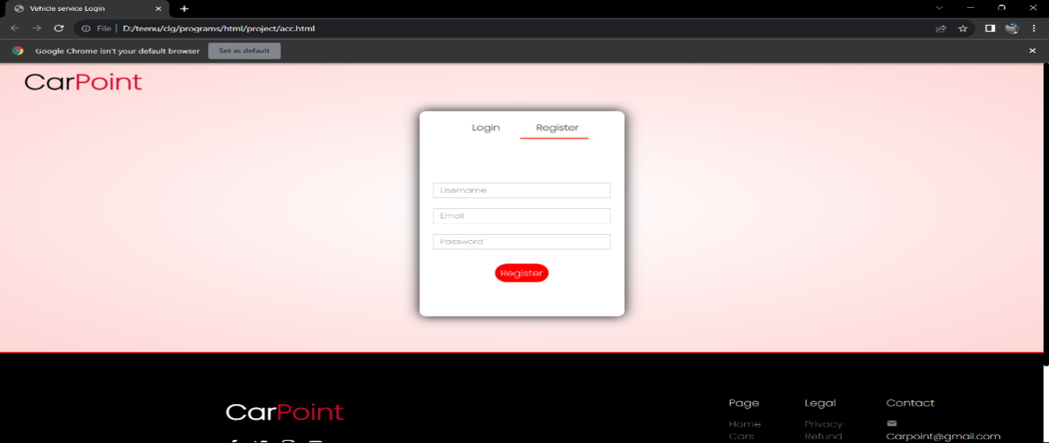

Fig 1. Login Page

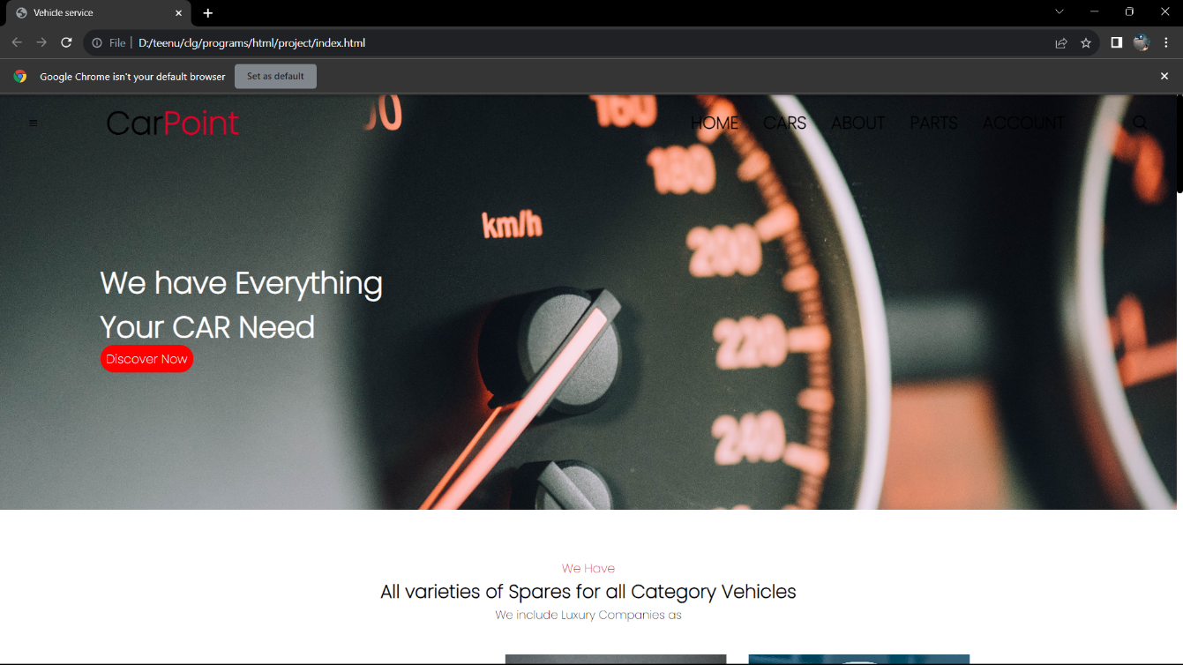

Fig 2. Main Page

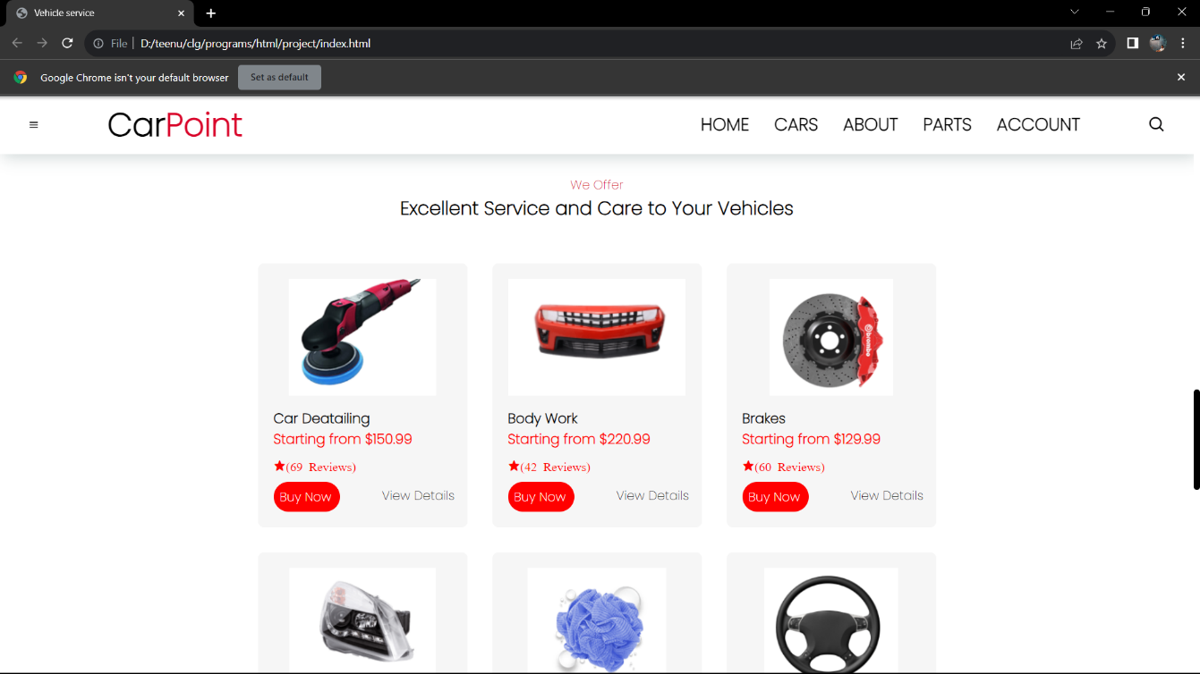

Fig 3.1. Category Page

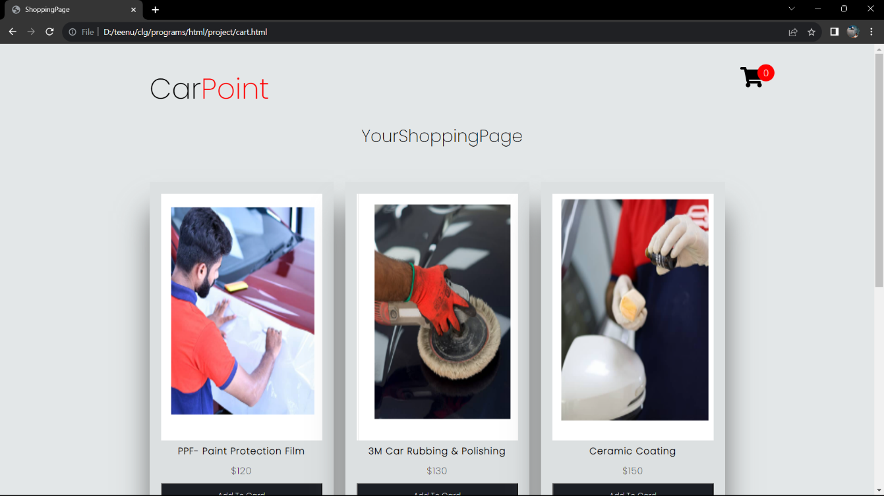

Fig 3.2. Shopping Page Result

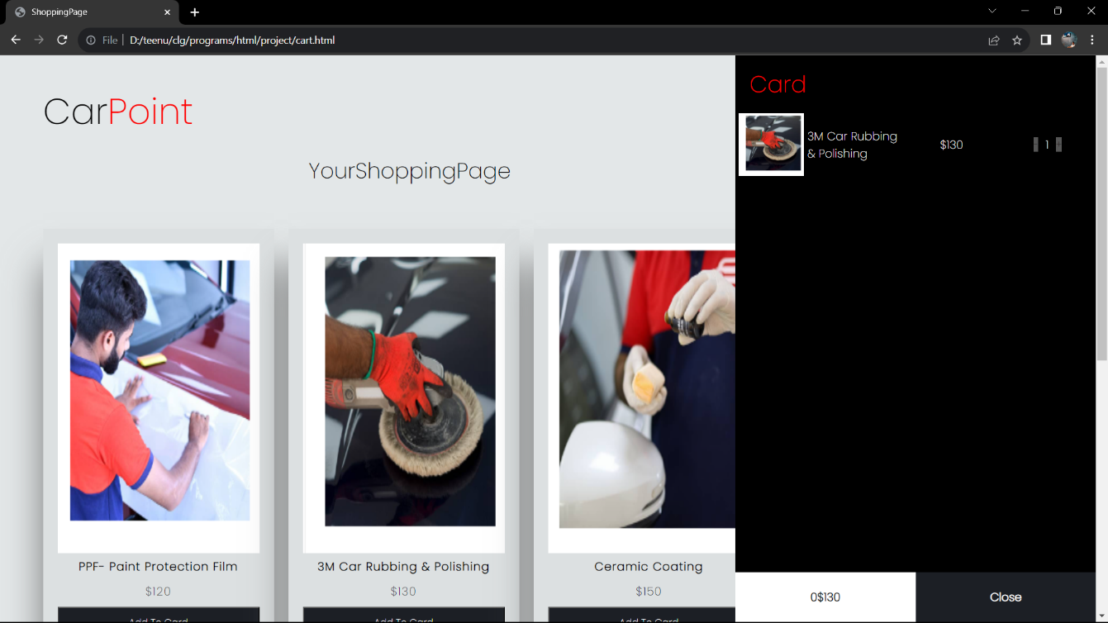

Fig 3.3 Cart Page Result